**Book Review Application**

**Software Engineering**

**Team VAD.com**

**Summer 2019**

**Members:**

Dong Jun Kim

Adrian McGhee

Venkata Satya Sai Vijayakrishna Kalavakolanu

Contents

Team Description 2

Planning and Scheduling 3

Teamwork Basics Summary 5

Work Norms: 5

Facilitator Norms: 5

Communication Norms: 5

Meeting Norms: 6

Handling Difficult behavior: 6

Handling Group Problems: 7

Problem Statement 8

System Requirements 9

Appendix 10

Team Communication Links 10

Slack: 10

Github: 11

Youtube: 12

Resumes: 13

Dong Jun Kim 13

Adrian D. McGhee 14

Venkata Satya Sai Vijayakrishna Kalavakolanu 15

# Team Description

|  |  |  |  |
| --- | --- | --- | --- |
| **Skills Capabilities Matrix** | | | |
| Team  Member | Computer Science  Education | Computing Skills  Inventory | Work Experience |
| Vijay Kalavakolanu | Undergraduate / Georgia State University Data Structures System level programming Computer Organization and Programming  Programming Language Concepts  Discrete Mathematics | JAVA C HTML Raspberry Pie JavaScript Debian OS Linux Microsoft Office Suite MySQL | Parallel Programming - project Logiware – intern Prance IT – intern |
| Dong Jun Kim | Undergraduate / Georgia State University Udemy / Online Classes DataCamp / Online Classes Principles of CS I & II Theoretical Foundations of CS Data Structures Computer Org System-Level Software Engineering | C Java Lua  MySQL Linux Python Assembly Hardware Troubleshooting AutoCAD Microsoft Word Visual Studio Computer Hardware Eclipse Unity | Computer Technician Quality Assurance Tester Mathematics Tutor |
| Adrian McGhee | A.S. Computer Science / Georgia State University Undergraduate / Georgia State University Comp Programming Non-Maj Computer Architecture Computer Org & Programming Computer Skills for Infor. Age Database Systems Design & Analysis: Algorithms Fund of Website Development Matlab Programming Intro to Computer Science Math Models for Computer Sci Programming Language Concepts System-Level Programming Software Engineering Big Data Programming | OBIEE Tableau Business Objects Crystal Reports PeopleSoft Toad Data Point Informatica ETL SQL PLSQL VBA Python SQL Server Oracle Visual Studio VB.net Microsoft Access Quality Center  Test Director DB2 TSO Siebel Matlab PowerBuilder | AT&T- Lead Quality Manager Analytics & Reporting (2015 - 2018) AT&T- Senior Quality/M&P/Process Manager (2013 - 2015) AT&T- Senior Specialist-Application Developer (2010 - 2013) AT&T- Senior IT Analyst (2007 - 2010) ACS - Systems Consultant Senior Analyst (2007 – 2007) ACS - Senior Professional Services Analyst (2005 – 2007) Accenture - Senior Systems Analyst (2004 – 2005) ACS - Business Analyst III (2002 – 2004) EDS - Advanced Business Analyst (2000 – 2002) DMR Consulting - Technical Consultant - Team Lead (1998 – 1999) EDS - Business/Software Analyst (1996 – 1998) |

# Planning and Scheduling

| **Team: DAV** | | | | | |
| --- | --- | --- | --- | --- | --- |
| **Assignee Name** | **Task** | **Duration  (hour)** | **Dependency** | **Due Date** | **Note(s)** |
| Doug, Adrian, Vijay | Task #0  **Team Meeting and Coordinator Election** | 1/2 hour | none | 6/18/2019 | Team members Doug, Adrian, and Vijay, agreed to elect Adrian as Assignment #1 team coordinator |
| Adrian | Task #1  **Team Capabilities Description** | 2 hours | Vijay, Doug, and Adrian must provide the following:   * Computer Science Education * Skills Inventory * Work Experience * Resume | 6/19/2019 | Conversion of resumes from .pdf to .docx is possibly needed.  Vijay and Dong provided completed resumes  All resumes merged to report format and verified content with team |
| Adrian | Task #2 **Planning and Scheduling** | 6 hours | Team members Doug, Vijay, and Adrian communicate daily regarding task statuses | 6/19/2019 | Vijay, Doug, and Adrian agreed the team name is DAV.  Each team member assigned tasks and due date(s) |
| Doug | Task #3 **Communication and Collaboration** | 2 hours | Doug will create Slack, GitHub, YouTube, accounts and provide login and password to all team members | 6/19/2019 | Doug sent team login and passwords for Slack, GitHub, and YouTube.   Screenshots for Slack and GitHub  requirements sent to team members via Slack.   Adrian corrected GitHub readme file with a change to project name. Vijay and   Vijay & Adrian verified Slack account and readme file and project setup in GitHub.   Adrian added screenshots to report document. |
| Vijay (task leader) Adrian | Task #4 **Teamwork Basics** | 4 hours | none | 6/20/2019 | Vijay submitted initial draft ahead of schedule. Doug and Adrian to review and provide edits if needed. |
| Doug, Adrian, Vijay | Task #5 **Project Topic** | 1/2 hour | Team members agreeing on project topic. | 6/18/2019 | Adrian, Vijay, and Dong agree to select Book Review Application as the target topic. |
| Vijay | Task #6 **Problem Statement** | 4 hours | Quality input from team members | 6/20/2019 |  |
| Doug, Vijay, Adrian | Task #7 **System Requirements** | 8 hours | Ability to determine specific high-level system requirements Need some type of modeling software to present diagram required | 6/21/2019 |  |
| Adrian (coordinator for assignment #1) | Task #8 **Report** | 17 hours | Must submit .pdf by 11:59PM 6/23/2019 Must submit hard copy of report to instructor's office between 12:00PM and 2:00PM on 06/24/2019 | 6/21/2019 |  |
| Adrian, Doug, Vijay | Task #9 **Video** | 3 hours | Vijay, Doug, and Adrian will meet on Saturday at 1:00PM in the GSU campus library 5th floor room 518 from 1:00PM - 4:00PM | 6/22/2019 | Team members will record video on smartphones |

# Teamwork Basics Summary

## Work Norms:

Work norms are fundamental in ensuring the overall success of any project involving multiple team members. More specifically, working as one in the spirit of teamwork is essential and necessitates that each member is equally an active participant in assigning individual team member tasks in conjunction with the weekly assignment coordinator. Likewise, promoting respectful dialog among team members is vital to the team's success. In the event of a dispute, each team member supports the weekly team coordinator decisions to resolve conflicts, utilizing individual judgment, based on factors which ensure overall success for the project.

To guarantee team success, the weekly team coordinator will carefully set and manage each team member’s weekly tasks by facilitating team meetings, providing task milestones and deadlines, and balancing workloads as needed. Furthermore, each week the project team members will actively participate in determining intermediate steps required to complete the weekly assignment.

Additionally, team members are expected to communicate and meet project deadlines established by the weekly team leader. In the event a team member foresees a potential to miss a deadline, the team member will notify the weekly team coordinator privately for assistance to resolve any obstacles preventing task delivery. Similarly, the weekly team leader will report any team member that habitually misses deadlines to the instructor and make a recommendation, along with the team, to assign a grade of zero for the week assignment and request remove of the member from the team.

Moreover, each team member’s work will be reviewed and evaluated for adherence to the weekly assignment requirements set by the instructor. The weekly team coordinator and team members will provide positive feedback to aid in proficiency development and foster successful task completion for the overall health of the project. Also, it is very common when working in groups for team members to have varying degrees of work habits ranging from the “do it right away” type to the last-minute procrastinator type. To reduce conflicts, team members should communicate assignment preferences and preferred deadlines to the weekly team coordinator and the entire team. Lastly, the team and the weekly coordinator will make every effort when possible to accommodate preferences as long as the preference does not cause a conflict in meeting the project goal.

## Facilitator Norms:

To establish and maintain order and promote positive teamwork, a team coordinator will be selected each week by the members of the team. Similarly, the rotation of the weekly team coordinator plays an important role in the development of each team member’s project management a leadership proficiency. A few of the team coordinator duties include, facilitating team meetings, project task assignment and management, coaching and development, dispute resolution, and project assignment preparation and submission. Additionally, the team coordinator will serve as the primary liaison between the project team and instructor.

## Communication Norms:

Each team member plays an essential role in the success of the overall project. Team members must always communicate with others professionally and respectfully and avoid dismissive, hostile, and combative behavior. Furthermore, at the core of any successful project is positive and open communication; to foster team collaboration, the project team will utilize the Slack application as the official source for team communications. Although Slack is the official source of team communication and essential messages, team members are also encouraged to select the best method of communication as necessary. These alternative methods of communication include official school email, mobile text messaging, and phone calls. Moreover, imperatively if other methods of communication are utilized, each team members will ensure the team coordinator and fellow team members are apprised as well. Similarly, Github will be utilized for communicating and storing project documentation and version control for source code.

## Meeting Norms:

(a) What is everyone’s schedule?

All of us are able to meet each other mostly on Wednesdays at 2:00pm.

(b) Should one person be responsible for coordinating meetings?

In general, with a group as small as this, there is no reason that a meeting should be held in the absence of any member. Therefore, while the coordinator may take initiative for suggesting meetings, details are to be agreed upon by all members except under extenuating circumstances.

(c) Do people have a preference for when meetings are held?

Meetings should be held when all group members are able to attend for the majority

of the meeting. I don't think we should have a major meeting if all members are not

able to attend and have time to contribute.

(d) Where is a good place to hold meetings?

Ideally, meetings are to be held in the library whenever possible.

(e) What happens if people are late to a meeting?

If the person has a legitimate excuse, then he/she will be excused the first time. But, if this continues, then he/she won’t be trusted to make important decisions.

(f) What happens if a group member misses a meeting?

If the person misses a meeting without an excuse, then the team coordinator will have a private talk with the person and depending on the significance of the absence, the professor will be contacted. But, as long as the person has a valid excuse, person will just have to prove that he/she is going to make up for the absence.

(g) What if he/she misses several meetings?

If a person misses several meetings and doesn't have a legitimate excuse, then the professor should be contacted about this. If the person misses several meetings because of a scheduling issue, then this should be worked out in this group to make sure we are doing everything possible to have all members included.

## Handling Difficult behavior:

being in a group can be as frustrating as it could be fun because obviously not everyone thinks alike. some of the behaviors that are the hard to deal with are: being over talkative, too quiet, argues too much, and/or complains too much.

“Many of us experienced all the above behaviors in our past at some point. I was the quiet one for most of my life until I got to college where I realized that communication is key to getting things done. one of the things that helped me overcome the shyness was actually one of my past teammates who kept asking me for my opinion throughout the assignments and actually applying my ideas into the project which made me realize that my opinion also matters so I know how important sharing ideas is because it contributes towards team building and efficiency.”

“

“

## Handling Group Problems:

Working in groups can make it much easier to finish the tasks at hand but at the same time when the group goes off topic too often it becomes that much harder to attain success at completing the assignment.

Working in a new group can be exciting but when the members spend too much time getting to know each other or spend too much time discussing things that are off topic it destroys the efficiency of that group. This can be resolved easily by drawing up a list of tasks and assign it each team member and setting a deadline to make sure everyone understands their role in the group. It also helps to say things like “can we go back to what we were talking about a minute ago and see what we can do?” or “hey I have an idea on that thing we were discussing about earlier”.

Decisions can be one of the most important and one of the most conflicting part of teamwork because people have different opinions on some matters and different ideas which each individual believes to be better than the rest. working in a group project in my 3210 class, I’ve had this problem when I was the team coordinator where two members had different ideas on a subject so I scheduled a meeting with the two members and listed out a pros and cons list according to themselves and we came to a collective decision on which idea was more effective. so as long as communication is open and harmless solutions can be made quite easily and it saves more time to talk it out than to have pointless arguments on ideas.

# Problem Statement

Our product is a book review app that lets you acquire the reviews of any book instantly by taking a picture of it. We use an image reading system to identify the book before searching platforms like amazon, Goodreads, and many other helpful sources. This makes the reviews precise due to the accuracy of the content we are searching for. This product is for all the book readers but specifically for high schools because they do a lot of summer reading assignments and it’s helpful for them to choose the more interesting books. it saves time and is more effective because it shows the reviews for the exact book you are looking for and nothing else. A few alternatives would be searching for the book manually on the internet or libraries, which take more time and is less accurate. This project is worth the time and effort to develop because not only does it help the customer but in cases like high schools or even college, the students who must read the books that the institution chose wouldn’t have to worry about reading monotonous books. To build this system we’ll be using “TINEYE” which lets us search using just an image and its API allows us to implement a graphical user interface which lets the customers to use their own images to search for reviews on the book they are looking for. This project is interesting because we will be combining two different platforms into making something very unique. We are using a reverse image search engine and linking it to sources like amazon, Goodreads, LibraryThing, and a few others. This saves the user from the need to search for the book manually, only thing they’ll need to do is take a picture and let our software do the rest.

# System Requirements

# Appendix

## Team Communication Links

### Slack:

|  |  |
| --- | --- |
| URL: | <https://softwareengin-yfd3984.slack.com/open> |

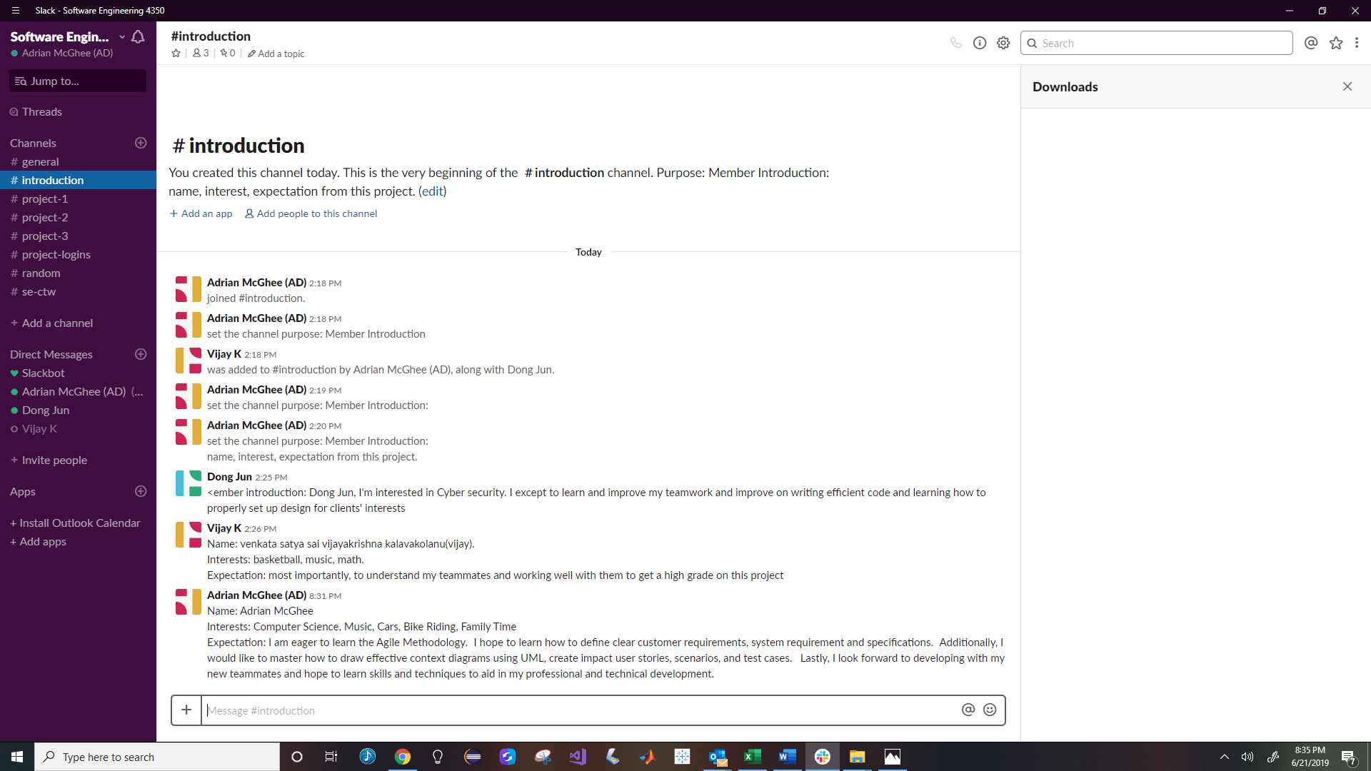

### Github:

|  |  |
| --- | --- |
| Username: | softwarebaku4350 |
| Password: | GSUPass123 |

Github Readme Screenshot:

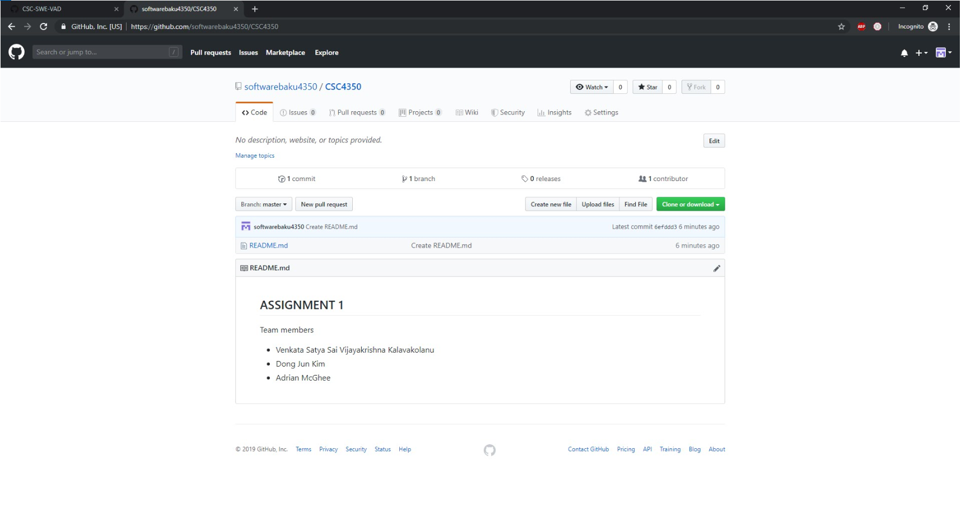

Github Project Screenshot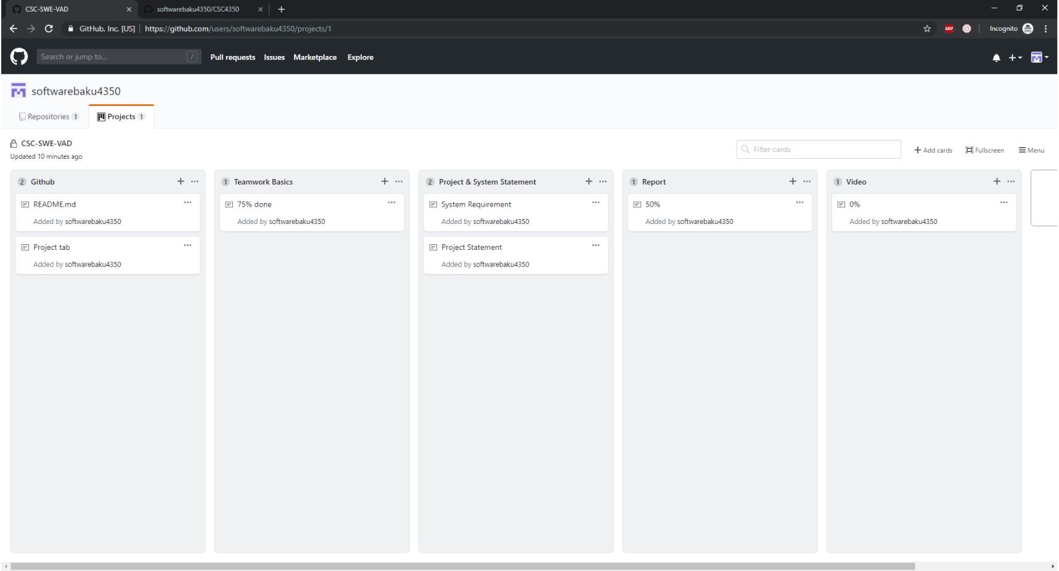

### Youtube:

|  |  |
| --- | --- |
| Username: | softwarebaku4350@gmail.com |
| Password: | GSUPass123 |

## Resumes:

### Dong Jun Kim



### Adrian D. McGhee

**AREAS OF EXPERTISE**

* Data Analysis / Datamart Design
* Quality Engineering
* Research & Analysis
* Business Objects / OBIEE / Tableau
* System Testing / Software Testing
* Reports / Dashboards/ Visualization Development
* Database Development and Management
* WMS (Warehouse Management Systems)
* Quality Assurance
* Supply Chain Forward & Reverse Logistics
* Device Warranty & Insurance
* SKU / IMEI/ RMA Management
* Software Application Consulting
* Quality Assurance

**TECHNICAL SUMMARY**

Business Objects, ADO.NET, C/C++, COBOL, Crystal Report, CSS, DB2, DOS, HTML, IBM 3090 MVS/TSO/CICS, IMS, Informix, Java, Java Script, JCL, Microsoft VB.NET, MS Access, MS SQL Server, OBIEE, Oracle, MySql, PeopleSoft, PowerBuilder, Python, Quality Center, Siebel, SPUFI, SQL, Test Director, TOAD, Unix, VBA

**KEY CAREER ACCOMPLISHMENTS**

* Serve as Technical SME for Quality Engineering & Reliability Team supporting 10+ Supply Chain Quality Engineers at American Telephone & Telegraph
* Design, code, implement, and maintain AT&T Supply Chain Quality Datamart development, staging, and production SQL Servers
* Produced automated BI Mobility Liquidated Damages Reporting resulting in recuperation of 4 million dollars annually
* Responsible for the creation and maintenance of multiple extract, load, and transform (ETL) processes from key AT&T source systems, comprise of consumer device sales and returns data; over 1 million aggregated transactions monthly for executive dashboards (Director, VP, and SVP)
* Responsible for coordinating and managing testing activities for the Georgia Medicaid Management Information System (MMIS), including regression, integration, smoke, functional, interoperability user acceptance, user interface and performance at Affiliated Computer Services (ACS)
* Lead Analyst during the implementation of the William D. Ford Federal Student Loan Consolidation program, implementing over 200 new batch jobs and loading initial client data to IMS/DB2 databases at Electronic Data Systems (EDS)

**CAREER HISTORY**

|  |  |  |  |
| --- | --- | --- | --- |
| Lead Quality Manager Analytics & Reporting | Entertainment Group - Supply Chain | AT&T (Atlanta, GA) | 2015 - 2018 |
| Senior Quality/M&P/Process Manager | Mobility Supply Chain & Fleet Operations | AT&T (Atlanta, GA) | 2013 - 2015 |
| Senior Specialist-Application Developer | Mobility Supply Chain & Fleet Operations | AT&T (Atlanta, GA) | 2010 - 2013 |
| Senior IT Analyst | Mobility Supply Chain & Fleet Operations | AT&T (Atlanta, GA) | 2015 - 2018 |
| Systems Consultant Senior Analyst | GlaxoSmithKline – PeopleSoft | ACS – Buck Consultants  (Atlanta, GA) | 2007 – 2007 |
| Senior Professional Services Analyst | Georgia DCH – GA Medicaid Program | ACS (Atlanta, GA) | 2005 – 2007 |
| Senior Systems Analyst | BellSouth – Siebel MAX Project | Accenture (Atlanta, GA) | 2004 – 2005 |
| Business Analyst III | Georgia DCH – GA Medicaid Program | ACS (Atlanta, GA) | 2002 – 2004 |
| **Advanced Business Analyst** | MetaVance Healthcare Administration & Finance | EDS (Atlanta, GA) | 2000 – 2002 |
| **Technical Consultant - Team Lead** | BellSouth Y2K Billing Tower | DMR Consulting (Birmingham, AL) | 1998 – 1999 |
| **Business/Software Analyst** | United States Department of Education | EDS (Montgomery, AL) | 1996 – 1998 |

**EDUCATION**

B.S. Computer Science candidate, Georgia State University, Fall 2020, GPA 3.5

A.S. Computer Science, Georgia State University, May 2016, GPA 3.33

### Venkata Satya Sai Vijayakrishna Kalavakolanu

**EDUCATION**

**Georgia State University**

Atlanta, GA

Bachelor of Science in Computer Science May 2020

**SKILLS AND ABILITIES**

**Coding:** JAVA, C, HTML, Raspberry Pie, JavaScript, Debian OS

**Technologies/Environment:** Linux, Microsoft Office Suite, MySQL,

**Selected Coursework:** Data Structures (JAVA), System level programming (C), Computer Organization And Programming ( LINUX ), Programming Language Concepts, Discrete Mathematics.

**WORK RELATED EXPERIENCE**

**Parallel Programming** - **project**

* Assigned tasks to multiple threads to run separate parts of my program simultaneously
* Incorporated Raspberry Pie for a more enhanced coding experience
* Used openMP to start up a Debian OS in a Linux environment and C to orient the parallel programming.

**Logiware** – **intern**

* organized work projects and schedule outline to increase efficiency of information access
* Used a multi-tier architecture focused primarily on the database tier to present and manage data belonging to multiple clients
* Stored data and created indices in tables using data queried in SQL
* Created web databases to store and key client information

**Prance IT** – **intern**

* Quality assurance testing of web applications.
* Created and executed software test plans, cases, and scrips to uncover, identify and document software problems and their causes.
* worked closely with development team to resolve infrastructural issues.
* Increased company growth and efficiency by documenting and reporting test findings to team.

OTHER EXPERIENCE

**Publix – cashier**

* Receive payments by cash, check, credit cards, vouchers, or automatic debits.
* Issue receipts, refunds, credits, or change dye to customers.
* Effectively managed my time and prioritized my tasks.
* Extensively acquired product knowledge and understanding of customers’ requirements.